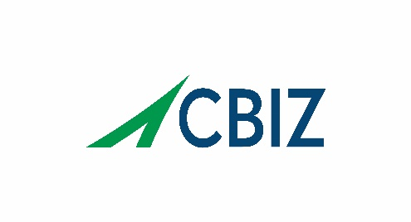
CBIZ Talent Solutions
4600 S Ulster St, Suite 900
Denver, CO 80237
Phone: 720-200-1725

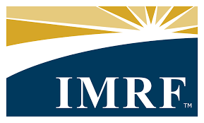

ILLINOIS MUNICIPAL RETIREMENT FUND

EXECUTIVE DIRECTOR POSITION PROFILE

THE ORGANIZATION

The Illinois Municipal Retirement Fund (IMRF) is a statewide public pension fund for local government employers and employees outside Chicago and Cook County and is among the nation’s largest and best-governed retirement systems. Created by the Illinois General Assembly, IMRF began operating in 1941 with five original employers and $5,000 in assets. Today, IMRF delivers retirement, disability, and death benefits for local public agencies, their employees, and beneficiaries serving more than 3,000 employers, 537,775 members and managing $60.9 billion in assets. With a funded status of 96.9%, IMRF is one of the best-funded public pension systems in the country. IMRF has earned national recognition for its funding discipline, customer engagement, operational excellence, and workforce success, including receiving the Malcolm Baldrige National Quality Award in 2019.

Headquartered in Oak Brook, Illinois, IMRF’s mission is to efficiently and impartially develop, implement, and administer programs providing income protection to members and their beneficiaries on behalf of participating employers in a prudent manner.

Learn more at www.imrf.org

FUND DATA (as of December 31, 2025)

Assets Under Management: $60.9 billion

Participants: 537,775

Active: 196,691

Retired & Beneficiaries: 159,455

Inactive: 181,629

Employers: 3,076

Annual Benefits Paid: $3 billion

Funded Ratio: 96.9%

Target Asset Allocation

US Equity: 32.5%

International Equity: 18%

Fixed Income: 24%

Private Real Assets: 10.5%

Alternative Investments: 14%

Cash: 1%

MISSION, VISION, AND CORE VALUES
IMRF’s vision and values support their mission statement by providing goals and guiding principles. With a mission to efficiently and impartially develop, implement, and administer programs that provide income protection to members and their beneficiaries on behalf of participating employers in a prudent manner, IMRF operates under the following vision and values.

Vision: Driven by our commitment to excellence, we deliver financial security and peace of mind.

Values:
- Respect – Recognizing the worth, uniqueness and importance of ourselves, our co-workers, and our membership builds collaboration and cooperation.
- Empathy – Being aware of the feelings of others and how our actions affect them enables us to be responsive to the needs of our membership.
- Accountability – Accepting responsibility for our actions cultivates the trust of our coworkers, members, and employers.
- Accuracy – Performing our duties in an accurate and timely manner ensures our members receive the service and benefits to which they are entitled.
- Courage – Embracing change with confidence and intelligent risk-taking fuels innovation and drives continuous improvement.
- Honesty – Acting with integrity and professionalism unites us and builds trust with our community.

STRATEGIC OBJECTIVES
The 2026-2028 Strategic Plan outlines the strategic goals IMRF aims to achieve. Those objectives include:

- Financial Health – Achieve and maintain a funding level that sustains the Plan
- Customer Engagement – Foster and maintain engaged members and employers
- Workforce Engagement – Foster and maintain an engaged workforce
- Operational Excellence – Provide efficient and effective service at a reasonable cost

GOVERNANCE AND STRUCTURE

Governed by: Board of Trustees composed of 8 members, elected by the people and institutions the fund is mandated to serve:

Four Executive Trustees elected by participating units of government

Three Employee Trustees elected by participating IMRF members

One Annuitant Trustee elected by IMRF annuitants

Plan Structure: Multi-tier, defined benefit plans (Regular, SLEP, ECO, Tier 1 and Tier 2)

THE OPPORTUNITY
Reporting to the IMRF Board of Trustees, the Executive Director is the chief executive officer and lead fiduciary for all management and operations of the Fund. Through 9 direct reports overseeing a team of 257 highly dedicated team members, the Executive Director will drive the Fund’s commitment to financial strength, operational excellence, exceptional customer service, strong internal controls, and Board, employee, and stakeholder engagement.

Core responsibilities include:
Organizational & Fund Administration
- Provide leadership to IMRF in achieving its mission and strategic plan
- Direct pension and benefits administration, oversee computation of benefits, reinstatements, and annuities
- Direct the preparation and maintenance of necessary and proper records

Board Governance & Board Relations
- Serve as primary liaison to the Board and its committees, preparing agendas and reports, and acting as official spokesperson
- Implement Board directives, policies, and investment guidelines
- Advise Board on issues requiring Board policy/ action
- Act as liaison between the Board and IMRF staff and other service providers
- Provide necessary staffing, support and resources to the Board and its committees

Financial Stewardship
- Safeguard the assets of IMRF by developing and implementing proper internal controls
- Monitor the operational and funded status of the benefit plans
- Develop, recommend to the Board, and manage an operating budget
- Prepare the Annual Comprehensive Financial Report (ACFR)
- Develop and deliver all operational reports to the Governor and General Assembly

Staff & Vendor Leadership
- Assist the Board in selecting external service providers including investment managers, investment consultants, actuaries, auditors, and fiduciary counsel
- Oversee all key external service providers

Actuarial & Audit Process
- Assist the Board in reviewing and adopting actuarial assumptions, funding methods, benefit option factors and actuarial valuation methods for IMRF
- Initiate the annual actuarial valuations, periodic actuarial experience studies and independent actuarial audits as required by Illinois State law or Board policy

Stakeholder & Community Engagement
- Foster effective and credible relationships with the members and beneficiaries, participating employers, employee and retiree organizations and other stakeholders such as State government officers, the media, and the public at large
- Effectively and positively represent IMRF as the official spokesperson for IMRF and the Board
Investments and Financial Stewardship
- Assist the Board in developing policies and procedures for investing IMRF assets
- Execute and manage investments in accordance with Board directives

DESIRED QUALIFICATIONS

Bachelor’s degree required

Seven (7)+ years executive experience in pension, benefits, or complex public financial organizations

Proven Board and stakeholder-facing leadership experience

Demonstrated success in leadership, staff development, strategic plan execution, continuous improvement, and workforce engagement

Strong knowledge of defined benefit plans, actuarial valuations, investments, auditing, and regulatory compliance

Proven track record of success with external stakeholder engagement and communication

Desirable credentials: JD, CPA, CFA, MBA/MPA or other advanced degree in a related field

ESSENTIAL SKILLS AND KNOWLEDGE

General

Pension administration, investments, accounting, benefits, and member services

Actuarial valuations, reporting, audits, budgeting, and contract compliance

Strong communication skills with the ability to translate complex topics for diverse audiences

Experience working with a Board of Trustees

Leadership & Management

Strategic thinker who is approachable and accessible

Build trust with staff, the Board, and other stakeholders

Comfortable engaging with members, beneficiaries, and employers

Effective leader fostering a positive, high-performance culture

Stakeholder Relations & Communication

Build relationships with the Board, government officials, employers, and external vendors

Strong communicator with the ability to represent IMRF in community and industry forums

Compliance, Reporting & Innovation

Ensure strict compliance with pension laws, regulations, and internal controls

Drive innovation in processes and technology, ensuring continuous improvement

FOCUS AREAS

Software Implementation – Continue to improve the efficiency of the recently implemented pension administration system (Horizon) and the related processes

Customer Service Orientation – IMRF aims to be a premier service organization and as such has high expectations related to service provided to employers, members, and annuitants.

Strategic Planning – The Board of Trustees has identified strategic planning as critical to the success of the organization.

Leadership Development and Succession Planning – Continued implementation of Leadership Development programs to support succession planning at the executive level will be important for ongoing organizational success.

COMPENSATION

Competitive Base Salary: IMRF offers a competitive hiring range of $300,000 - $400,000 depending on qualifications and experience. The Executive Director also receives an IMRF provided cell phone and computer/tablet.

Additionally, IMRF offers a comprehensive, competitive benefits package.

Benefits package includes:

Pension Plan participation through IMRF

Health Insurance

Dental Insurance

Vision Insurance

Life Insurance

Tuition Reimbursement

Vacation, Sick, and Personal Time

Wellness Program

ABOUT OAK BROOK

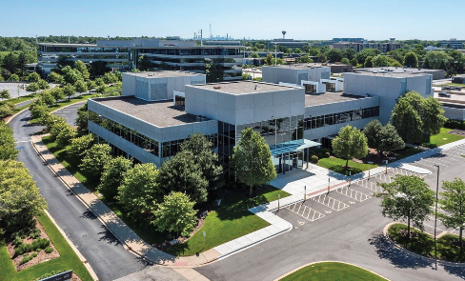
IMRF is headquartered in Oak Brook, a vibrant western suburb of Chicago. Oak Brook combines premier business centers, world-class shopping, excellent schools, golf courses, and expansive forest preserves, while remaining just 15 miles from downtown Chicago and within easy reach of O’Hare and Midway airports. The village offers exceptional amenities for professionals and families, and is routinely recognized for its quality of life, safety, and cultural offerings.

To learn more about living in Oak Brook visit:

- Oak Brook Chamber of Commerce
- Visit Oak Brook (Village)
- Oak Brook Area Travel & Tourism

APPLICATION PROCESS
CBIZ, an executive search firm, is assisting the Fund with this important search. All calls and inquiries should be made through the search firm. Applications will be held in confidence.

Please Apply here: Executive Director or email: tamara.wesely@cbiz.com

NON-DISCRIMINATION

Our client and CBIZ firmly support the principle and philosophy of equal opportunity for all individuals, regardless of age, race, gender, creed, national origin, disability, veteran status or any other protected category pursuant to applicable federal, state or local law.

CONTACT:

Kimberly Bradney
VP & Executive Search Consultant
Kim.bradney@cbiz.com
720-200-1725

Tamara Wesely
Recruiting Consultant
Tamara.Wesely@cbiz.com
720-200-1723

